SQL Project Udacity Questions and Solution

Question Set 1 – Question 1

1] Which Country/Countries have the most invoices?

SELECT BillingCountry, Count(*) AS Invoices

FROM Invoice

ORDER BY 2 DESC;

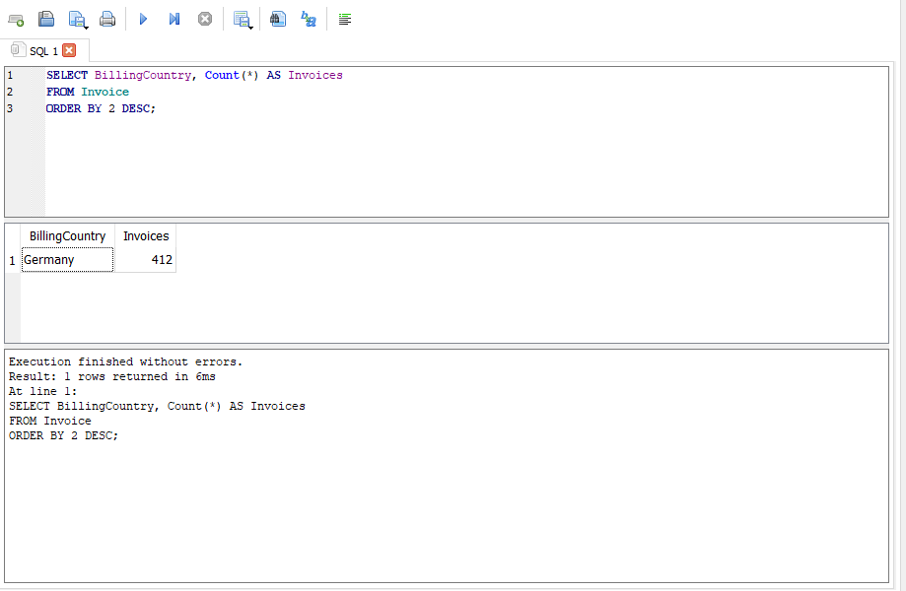

2]Which City has the best customers?

SELECT BillingCity AS 'BillingCity', SUM(Total) AS 'InvoiceDollars'

FROM Invoice

GROUP BY 1

ORDER BY 2 DESC

LIMIT 1;

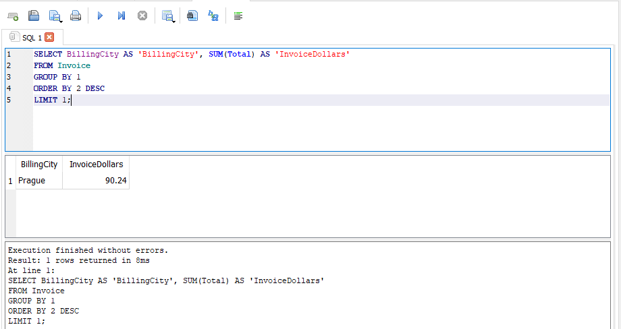

3]Who is the best customer?

SELECT Customer.FirstName, Customer.LastName,Customer.CustomerId, SUM(Total)total_spending

FROM Invoice

JOIN Customer ON Customer.CustomerId = Invoice.CustomerId

GROUP BY 1,2

ORDER BY 4 DESC

LIMIT 1;

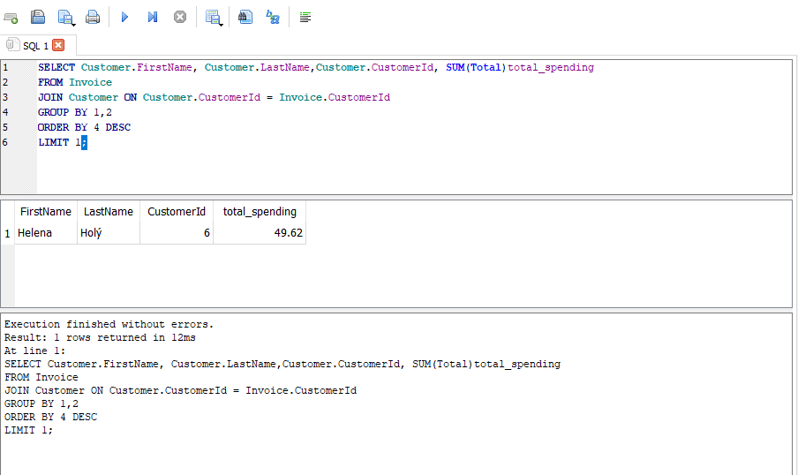

Question Set 2 – Question 1

SQL Code:

SELECT DISTINCT Customer.Email,Customer.FirstName,Customer.LastName,Genre.Name

FROM Customer

JOIN Invoice ON Customer.CustomerId = Invoice.InvoiceId

JOIN InvoiceLine ON InvoiceLine.InvoiceId = Invoice.InvoiceId

JOIN Track ON Track.TrackID = InvoiceLine.TrackId

JOIN Genre ON Genre.GenreId = Track.GenreId

WHERE Genre.Name = 'Rock'

ORDER BY 1;

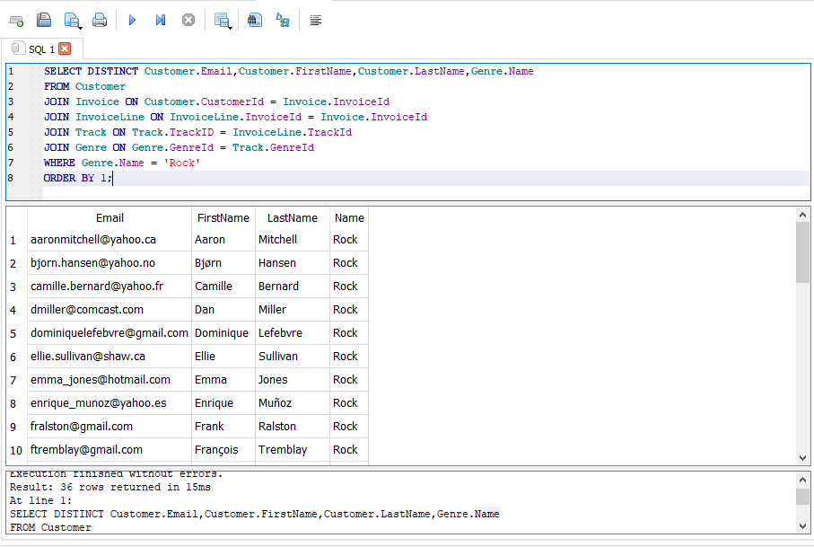

Question Set 2 – Question 2

SQL Code:

SELECT Artist.ArtistId AS 'ArtistID', Artist.Name AS 'NAME', COUNT (Track.TrackId) AS 'Songs'

FROM Artist

JOIN Album ON Artist.ArtistId = Album.ArtistId

JOIN Track ON Album.AlbumId = Track.AlbumId

JOIN Genre ON Track.GenreId = Genre.GenreId

WHERE Genre.Name = 'Rock'

GROUP BY 1,2

ORDER BY 3 DESC

LIMIT 10;

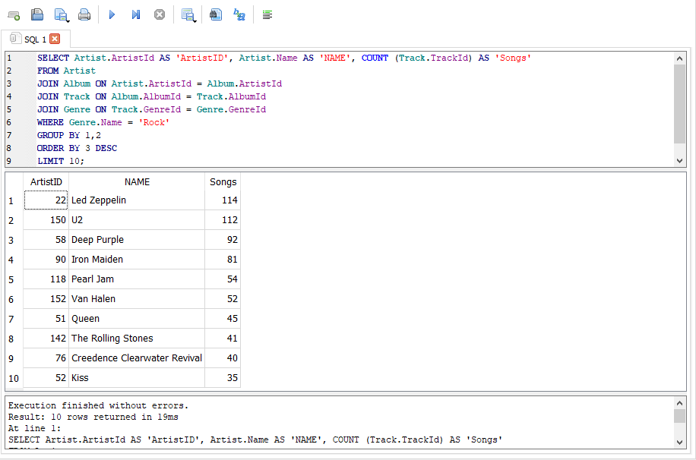

Question Set 2 – Question 3 [Part 1]/T1

Which artist has earned the most according to the InvoiceLine?

SELECT Artist.Name AS Name,SUM(InvoiceLine.Quantity * InvoiceLine.UnitPrice) AS AmountSpent

FROM Artist

JOIN Album

ON Artist.ArtistId = Album.ArtistId

JOIN Track

ON Track.AlbumId = Album.AlbumId

JOIN InvoiceLine

ON track.TrackId = InvoiceLine.TrackId

JOIN Customer

ON customer.customerId = invoice.CustomerId

JOIN Invoice

ON Invoice.InvoiceId = InvoiceLine.InvoiceId

GROUP BY 1

ORDER BY 2 DESC;

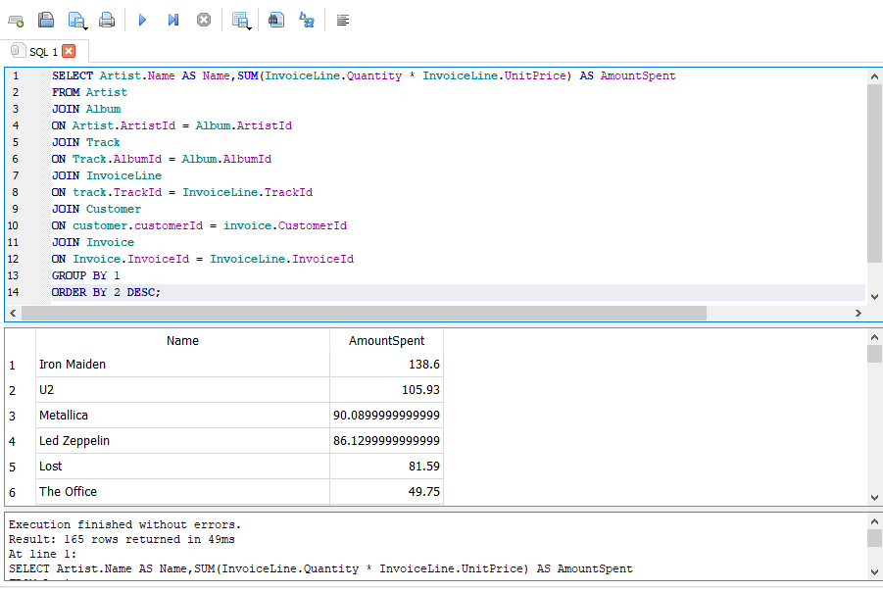

Question Set 2 –Question 3 [Part 2]/T2

How much of each product was purchased by? [Each customer for Iron Maiden]

SELECT Artist.Name AS Name,SUM(InvoiceLine.Quantity*InvoiceLine.UnitPrice) AS AmountSpent,

Customer.CustomerId AS CustomerID, Customer.FirstName AS FirstName,Customer.LastName AS LastName

FROM Artist

JOIN Album

ON Artist.ArtistId = Album.ArtistId

JOIN Track

ON Track.AlbumId = Album.AlbumId

JOIN InvoiceLine

ON track.TrackId = InvoiceLine.TrackId

JOIN Customer

ON customer.customerId = invoice.CustomerId

JOIN Invoice

ON Invoice.InvoiceId = InvoiceLine.InvoiceId

WHERE Artist.Name = 'Iron Maiden'

GROUP BY 3,4,5

ORDER BY 2 DESC;

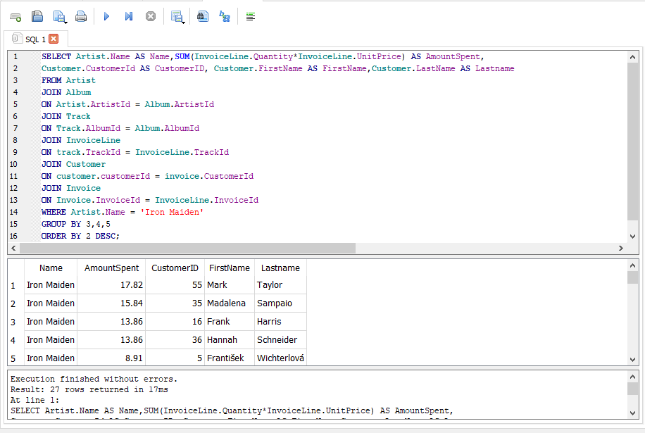

Advanced SQL : Question Set 3

Question 1 – We want to find out the most popular music Genre for each country. We determine the most popular genre with the highest amount of purchases. Write a query that returns each country along with the top Genre. For Countries where the maximum number of purchases is shared return all Genres.

WITH

T1 AS

(SELECT

Invoice.BillingCountry,

COUNT(InvoiceLine.InvoiceId) AS Purchases,Genre.Name,Genre.GenreId

FROM Invoice

JOIN InvoiceLine

ON Invoice.InvoiceId = InvoiceLine.InvoiceId

JOIN Track

ON Track.TrackId = InvoiceLine.TrackId

JOIN Genre

ON Genre.GenreId = Track.GenreId

GROUP BY 1,3,4),

T2 AS

(SELECT

T1.BillingCountry,MAX(T1.Purchases) AS Purchases

FROM T1

GROUP BY 1)

SELECT

T1.Purchases,T1.BillingCountry AS Country,T1.Name,T1.GenreId

FROM T1

JOIN T2

ON T1.BillingCountry = T2.BillingCountry

AND T1.Purchases = T2.Purchases;

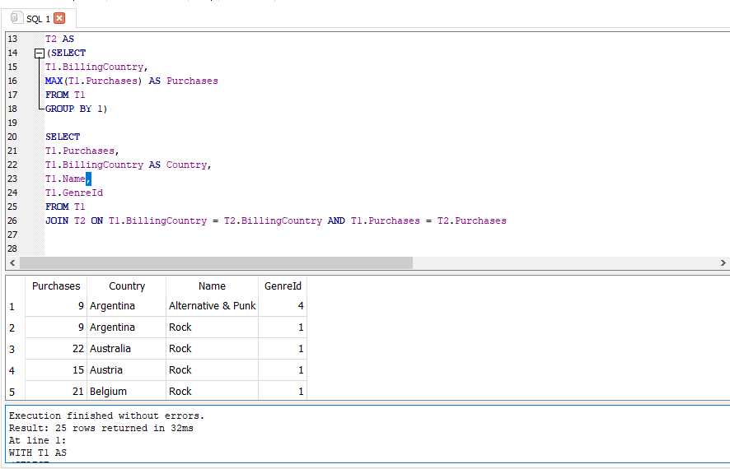

Question 2

Return all the track names that have a song length longer than the average song length. Though you could perform this with two queries. Imagine you wanted your query to update based on when new data is put in the database. Therefore, you do not want to hard code the average into your query. You only need the Track table to complete this query.

Return the Name and Milliseconds for each track. Order by song length with the longest songs listed first.

There should only be 494 of the 3503 track in your table.

SELECT Name, Milliseconds

FROM Track

WHERE Milliseconds>(SELECT AVG (Milliseconds) FROM TRACK)

ORDER BY 2 DESC;

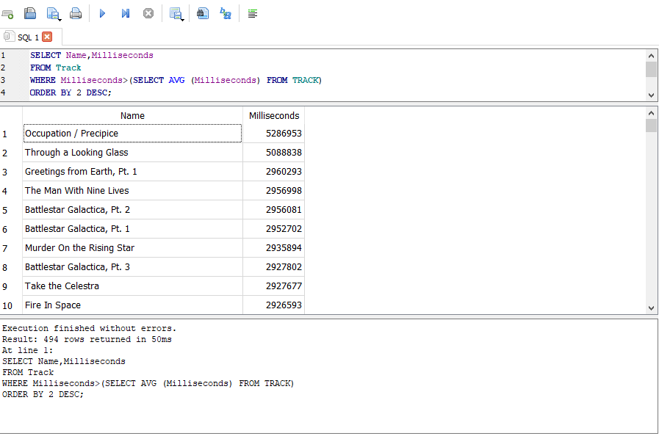

Question 3 Write a query that determines the customer that has spent the most on music for each country. Write a query that returns the country along with the top customer and how much they spent. For countries where the top amount spent is shared, provide all customers who spent this amount.

Use only the Customer and Invoice table.

Columns : Country, TotalSpent, FirstName, LastName,CustomerId.

Should return 25 rows. UK has two listing. Order By Country.

WITH

T1

AS(SELECT Customer.Country,SUM(Invoice.Total) AS TotalSpent,Customer.FirstName, Customer.LastName,Customer.CustomerId

FROM Customer

JOIN Invoice

ON Customer.CustomerId = Invoice.CustomerId

GROUP by 1,5),

T2

AS(SELECT T1.Country,MAX(TotalSpent)AS TopTotal,T1.FirstName,T1.LastName,T1.CustomerId

FROM T1

GROUP BY 1)

SELECT T1.*

FROM T1

JOIN T2

ON T1.Country = T2.Country

WHERE T1.TotalSpent = T2.TopTotal

ORDER by 1;

